OOP: Practice Lab 1 - Create a Class
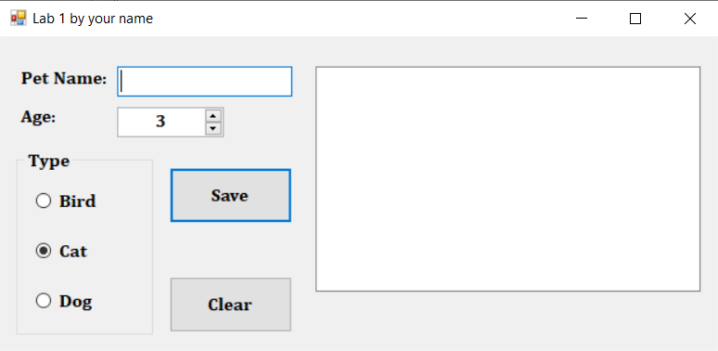
+
Create a project LastnameLab1 with a form that looks like this:
- Font: Cambria bold 12 point
- Form Size: 635, 310
- Center when run
- Accept: Save and Cancel: Clear button set
- Tab order top to bottom then listbox
- Alignment as seen

- Add a class called Pet to your project and add the fields, properties and methods as shown here in this order:
Fields Description
name private string (stores the pet’s name)
age private integer (stores the pet’s age)
type private string (stores the pet type)
Property Description
Name Get or set the field that contains the pet’s name
Age Get or set the field that contains the pet’s age
Type Get or set the field that contains the pet’s type
Methods Description – reference properties (not fields)
Pet() Default constructor: Create a default pet as per the information found in the screenshots.
Pet(name, age, type) Send in data from the form (name, age and type). Age is found in the numericupdown and type is determined from the radiobuttons. Set the properties to the data sent in.
DisplayPet() No data sent. Return a string that contains all data formatted as seen in screen shots on next page.

- Clear: create a function ResetForm that resets to the form seen above with the cursor on the textbox. No data is sent or returned. Call the function from the form load and Clear button. Clears the listbox too.
- Save button: (pseudocode) Do not clear listbox each time!
If there is no data in the textbox
Create a pet using the default constructor
The age should then be set to 1 more than the numeric up-down
(Think about this: What does this line of code call? The get or the set?)
Else
Create a pet using the other constructor and the controls on the form
End IF
Call the DisplayPet method and place the pet data in the listbox.
- Comments: comment the class definition window. Add a comment header to the form window with your name, date, and description. Comment every event and method in the form window. Comment the date at the end of the code.
- Submission:
Zip entire program (top level folder) and submit to Brightspace. No memo required.
Screenshots: one long run
Form Load and Clear: shown on top of previous page
Textbox empty and Save:
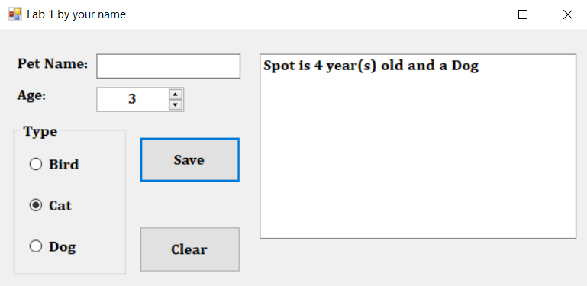

Data as seen below and then Save: (no Clear between)
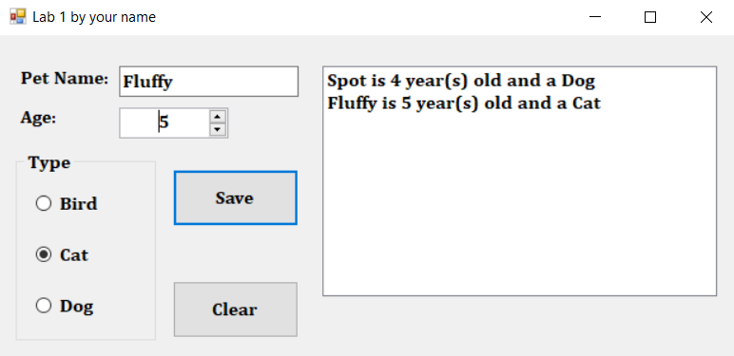

Data as seen below and then Save: (no Clear between)
